CREDIT CARD FRAUD DETECTION USING MACHINE LEARNING
Methodology, Novelty and Key Contributions
Department of Computer Science and Engineering, TKR College of Engineering & Technology
Batch A4 (CSE-A) · Academic year [ACADEMIC YEAR]
Table 1: Project team
S.No. | Student name | Roll number
1 | ARELLI PRAVEEN KUMAR | 23K91A0513
2 | BANOTHU AJAY | 23K91A0529
3 | D CHANDRIKA | 23K91A0557
4 | BAIRAGONI VIJAY | 23K91A0525

Project guide: KOTESHWAR RAO
Chapter and section numbers quoted in the text (for example Chapter 8 or Section 6.2) refer to the full project report, 17.Final Document. Figures and tables in this document are numbered from 1.

1. METHODOLOGY
This document describes how SecurePay AI works from end to end and what is new in it. Part 1 gives the pipeline, the data, the algorithms and the reasons they were chosen; Part 2 sets the work against the base paper and separates what is new from what is standard; Part 3 lists the contributions.

1.1 Overall methodology
SecurePay AI follows the method of the base paper [1]: a Gaussian-Bernoulli restricted Boltzmann machine classifier (GRBMC) is trained on a balanced set of card transactions with three different procedures for estimating the model's negative-phase statistics - classical persistent contrastive divergence (PCD), simulated-annealing sampling (SAS) and quantum sampling (QS). The project adds what the paper does not describe: a complete preprocessing pipeline that can be re-run from the interface, an ensemble of the three trained models, a three-band decision rule for live scoring, a REST API, a web application, and a measured comparison against conventional classifiers. The work is organised in seven steps.
1. Acquire data. Generate a synthetic, balanced file of 39,000 transactions that imitates the paper's balanced set (the real data is proprietary).
2. Preprocess. One-hot encode the categorical fields, z-score the numeric fields, drop highly correlated columns, balance the classes, rank the features with a random forest and keep the 18 best, then split 80/20 with stratification.
3. Train. Fit three GRBMC models (PCD, SAS, QS) epoch by epoch, scoring the held-out split after every epoch and writing the metric history to disk.
4. Decide. Average the three fraud probabilities and map the result to approve, challenge or decline.
5. Serve. Expose the pipeline and the models through a Flask API with 16 routes and a React interface.
6. Evaluate. Report precision, recall, F1 and ROC-AUC rather than accuracy alone, against Logistic Regression, Random Forest and XGBoost, across five random seeds, across decision thresholds and on a variant with 1 % fraud.
7. Document. Regenerate every number in the documentation from experiments/metrics.json so that nothing is typed by hand.
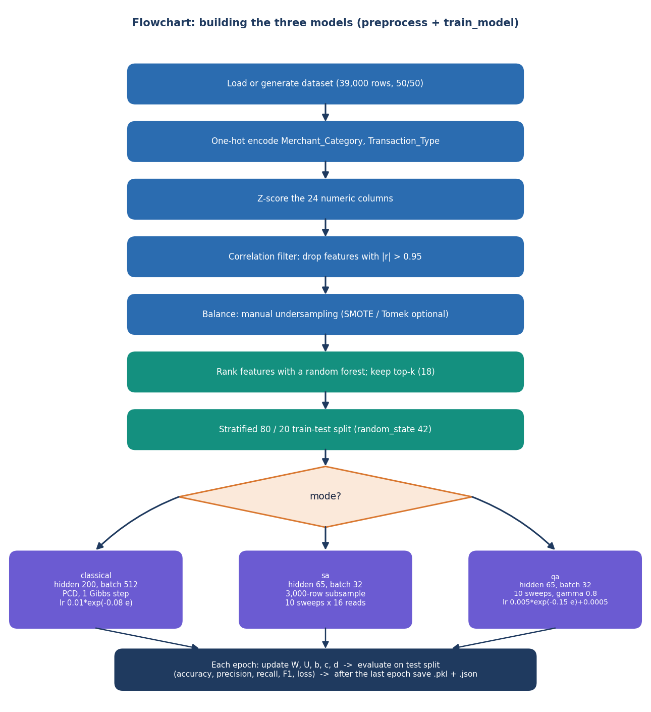
Figure 1: Core algorithm: preprocessing and the per-epoch training loop of the three GRBMC trainers.
Two properties of the method deserve to be stated at the start. First, the three trainers share one model class and one prediction rule; they differ only in how the negative phase of the gradient is sampled, so any difference in their results is a difference in sampling. Second, the SAS and QS samplers in this project are simplified classical approximations written in NumPy: they are not the path-integral Monte Carlo procedure of the paper's simulator and they do not call quantum hardware. Section 6.6 spells out the differences, and every later chapter refers to QS as quantum-inspired for that reason.

1.2 Dataset
The base paper's data are 145 million real transactions from a Brazilian payments company, of which about 19 thousand are fraudulent; the authors undersampled it manually to a 39 thousand-row set with a 50/50 split [1]. That data is not public, so this project generates a synthetic file with the same size and balance. backend/synthetic_data.py draws the legitimate and the fraudulent class from different distributions with a seeded NumPy generator (seed 42). The saved file data/creditcard_synthetic.csv has 39,000 rows and 29 columns: 19,500 fraudulent and 19,500 legitimate transactions. No licence restriction applies because every value is generated.
Table 2: Columns of the synthetic transaction file
Column(s) | Type | Legitimate class | Fraudulent class
Amount | continuous | |N(80, 60)| (mean 85.21 in the file) | |N(350, 250)| (mean 368.20 in the file)
Time | integer seconds, 0 to 7,776,000 | uniform over 90 days | uniform over 90 days
Merchant_Category | 7 categories | mostly Grocery 25 %, Restaurant 20 %, Fuel 15 %, Online 15 % | mostly Online 35 %, Electronics 25 %, Travel 15 %
Transaction_Type | Chip, Contactless, Online, Swipe | Chip 40 %, Contactless 30 %, Online 20 %, Swipe 10 % | Online 60 %, Contactless 15 %, Swipe 15 %, Chip 10 %
Card_Present | 0 / 1 | present in 80 % of rows | present in 30 % of rows
Country_Match | 0 / 1 | match in 95 % of rows | match in 60 % of rows
V1 ... V22 | continuous, standard normal | N(0, 1); V1 raised slightly with Amount | N(0, 1) with shifts on V3 (+1.5), V7 (-1.2), V10 (+1.0), V14 (-0.8), V17 (+1.3)
Class | 0 / 1 | 0 = legitimate | 1 = fraud

The columns V1 to V22 imitate the anonymised principal-component features that published card datasets use; here they carry no meaning other than the shifts listed in the table. The web interface labels V3, V14 and V17 as history signal, location variance and spending pattern to make the form readable, but those are friendly names for synthetic features and not real card-holder attributes. Because the classes are generated from different distributions the problem is easier than real fraud, and the results in Chapter 8 must be read with that in mind.
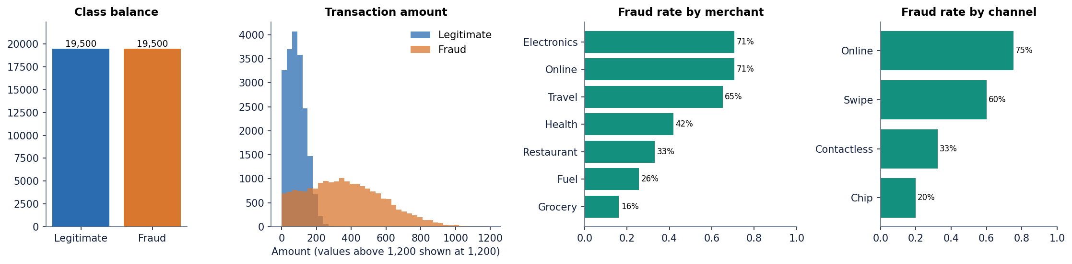
Figure 2: Synthetic dataset: class balance, transaction amount by class, and fraud rate by merchant category and by channel.
The file is balanced by construction. The base paper started from an extremely imbalanced stream and found that SMOTE and Tomek links performed poorly because the minority class was tiny, so it fell back to manual undersampling [1], [12], [13]. To see what happens when this project's pipeline meets a realistic imbalance, the experiment script also builds a variant with 39,000 rows of which 1 % are fraud (390 fraudulent rows); it is used only for evaluation in Chapter 8 and is never loaded by the application.

1.3 Preprocessing
The preprocessing code is backend/preprocessing.py, function full_pipeline. The application's start-up code and the experiment script both apply it to an 8,000-row random sample of the file (random_state = 42), which keeps the interactive steps fast. The steps follow Section III-A of the base paper [1] and are summarised below with the real shapes they produce.
Table 3: Preprocessing steps and the data shapes they produce
Step | What the code does | Shape afterwards
1. Sample | df.sample(8000, random_state=42) from the 39,000-row file | 8,000 x 29 (28 features + Class)
2. One-hot encoding | pd.get_dummies on Merchant_Category (7) and Transaction_Type (4), float dtype | 8,000 x 38 (37 features + Class)
3. Z-score | StandardScaler fitted on the 24 numeric columns (Amount, Time, V1 to V22); the 2 binary and 11 dummy columns stay 0/1 | unchanged
4. Correlation filter | drop any column whose absolute correlation with an earlier column exceeds 0.95 | no column dropped (37 features)
5. Balancing | manual (default): keep all fraud rows and a random legitimate sample of size min(n_fraud, n_legit); smote and tomek are optional | 8,000 rows (the sample is already balanced, so nothing is removed)
6. Feature ranking | random forest (200 trees, seed 42) on the balanced set; keep the 18 highest importances | 8,000 x 18 + Class
7. Split | train_test_split(test_size = 0.2, stratify = y, random_state = 42) | train 6,400 x 18 (3,218 fraud); test 1,600 x 18 (805 fraud)

Z-score. Gaussian visible units expect inputs with zero mean and unit variance, so every numeric column x is replaced by
z = (x - μ) / s (1)
where μ and s are the column mean and standard deviation of the 8,000-row sample. The fitted scaler is stored in models/pipeline.pkl together with the kept column names and the importance table, so that the serving code can transform a new transaction the same way. Section 6.10 describes a defect in how the batch route uses that scaler.
Feature ranking. The base paper ranks features with CatBoost [21]. CatBoost is not in this project's requirements, so feature_importance_filter falls back to a random forest [19] when the import fails; that is what ran here. The ten strongest features are Amount, V3, Card_Present, V17, V7, Country_Match, V10, Transaction_Type_Online, V14 and Transaction_Type_Chip, which matches the way the generator separates the classes. The 18 kept features are Amount, V3, Card_Present, V17, V7, Country_Match, V10, Transaction_Type_Online, V14, Transaction_Type_Chip, Merchant_Category_Grocery, V1, V6, V16, V2, V11, V4, V19. The merchant dummy for Grocery and the low-importance columns V1, V6, V16, V2, V11, V4 and V19 are included only because 18 slots are requested.
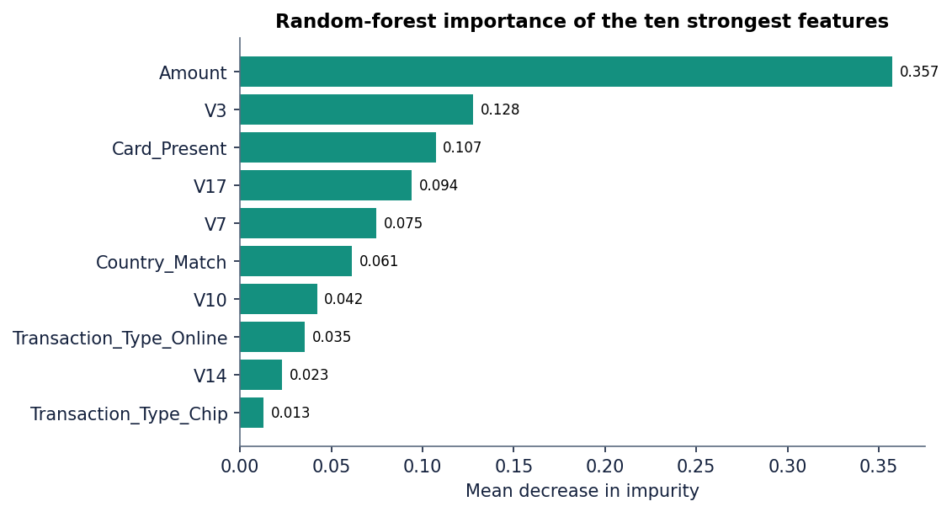
Figure 3: Random-forest feature importance for the ten strongest of the 18 selected features.
Order of operations. Scaling, balancing and feature ranking are all fitted on the whole 8,000-row sample before the train/test split, so the test rows have influenced the scaler and the feature ranking. On this balanced synthetic file the effect is small (the scaler statistics barely move and the ranking is dominated by the same features), but it is a leak that a careful pipeline would avoid by fitting on the training rows only. The experiments in Chapter 8 that compare strategies on the 1 % variant do split first and fit the scaler and the resampler on the training rows only.

1.4 Algorithm choice and justification
The choice of model is the base paper's, and this section records why it was kept and what was added beside it.
• Why a GRBM classifier. A restricted Boltzmann machine is an energy-based network whose energy function can be written as a quadratic unconstrained binary optimisation (QUBO) problem [1], [22], [26]. Adding a label layer joined to the hidden units turns the generative model into a classifier [27], and Gaussian visible units let it read z-scored continuous features [28]. The structure is small (a few thousand weights), trains in seconds on a CPU and gives a probability that can be thresholded.
• Why three trainers. Contrastive divergence and its persistent variant approximate the negative phase with Gibbs sampling [23], [24], [25]. Replacing the Gibbs chain by an annealing sampler is the idea the paper evaluates on a D-Wave simulator and on quantum hardware [30], [31]. Keeping all three in one code base makes the comparison direct: same data, same model class, same evaluation.
• Why simulate rather than call hardware. Quantum annealing hardware was not available to the project. The sampler is therefore a classical program that mimics the annealing schedule and a transverse-field tunnelling term. This keeps the structure of the paper's experiment but cannot test its claim about quantum advantage; the project makes no such claim [1].
• Why an ensemble. The three models make different errors (Chapter 8), and averaging their probabilities gives a smoother score than any single model. The ensemble also lets the interface show per-model scores beside the combined verdict.
• Why also run Logistic Regression, Random Forest and XGBoost. The batch objectives ask for these classifiers [4], [2], [20]. They are trained by scripts/run_experiments.py on exactly the same split so that the RBM is judged against standard baselines instead of against itself. They are not part of the shipped application.
Why undersample. Random undersampling to a 50/50 set keeps only real transactions, which is what the base paper chose after SMOTE and Tomek links failed on its extremely rare minority class [1], [12], [13], [14]. It has a known cost: undersampling distorts the posterior fraud probability unless it is recalibrated [11]. Chapter 8 measures that cost on the 1 % variant, where the undersampled models raise hundreds of false alarms.

1.5 Mathematical formulation

1.5.1 The Gaussian-Bernoulli RBM classifier
Let v be the vector of n_v = 18 Gaussian visible units, h the vector of n_h binary hidden units and y a one-hot label with two units. The model has weight matrices W (visible to hidden) and U (label to hidden) and bias vectors c, b and d for the three layers. Following Appendix A of the paper [1], extended with the label layer, the energy is
E(v, h, y) = Σᵢ (vᵢ − cᵢ)² / (2σ²) − Σⱼ bⱼ hⱼ − Σᵢⱼ (vᵢ / σ) Wᵢⱼ hⱼ − Σₖ dₖ yₖ − Σₖⱼ yₖ Uₖⱼ hⱼ (2)
and the joint distribution is p(v, h, y) = exp(−E) / Z, where the partition function Z sums over every configuration and is intractable. The code fixes σ = 1 (inputs are z-scored). The conditional distributions used for sampling are
p(hⱼ = 1 | v, y) = sigmoid( bⱼ + Σᵢ vᵢ Wᵢⱼ / σ + Σₖ yₖ Uₖⱼ ) (3)
p(v | h) = N( c + σ W h , σ² ) p(y = k | h) = softmaxₖ( dₖ + Σⱼ Uₖⱼ hⱼ ) (4)
The first is _visible_to_hidden_prob, the second _hidden_to_visible_params and _hidden_to_label_prob in backend/rbm_classifier.py.

1.5.2 Prediction by free energy
To classify a transaction the model compares the two label hypotheses y = 0 and y = 1 through the free energy with the hidden units summed out. As coded in predict_proba,
F(v, y) = − Σᵢ cᵢ vᵢ / σ − Σₖ dₖ yₖ − Σⱼ ln( 1 + exp( bⱼ + Σᵢ vᵢ Wᵢⱼ / σ + Σₖ yₖ Uₖⱼ ) ) (5)
P(fraud | v) = exp(−F(v, 1)) / ( exp(−F(v, 0)) + exp(−F(v, 1)) ) (6)
The visible term of F is linear in v (the exact Gaussian expression has a quadratic term) and does not depend on y, so it appears identically in F(v, 0) and F(v, 1) and cancels in the ratio; the simplification therefore does not change the prediction. A transaction is labelled fraud when P(fraud | v) exceeds 0.5. The probability is not calibrated: it is the posterior of an approximately trained energy model, which is why the shipped PCD model, whose ROC-AUC is 0.986, still flags almost every transaction at the 0.5 threshold (Chapter 8).

1.5.3 Training by persistent contrastive divergence
The log-likelihood gradient is the difference between a data-dependent (positive) and a model-dependent (negative) expectation [22], [25]. For a batch of m examples the code computes, with the positive hidden probabilities p⁺ from the data and the negative statistics (v⁻, y⁻, p⁻) from a sampler,
ΔW = (vᵀ p⁺ − (v⁻)ᵀ p⁻) / (m σ) ΔU = (yᵀ p⁺ − (y⁻)ᵀ p⁻) / m (7)
Δb = mean(p⁺ − p⁻) Δc = mean(v − v⁻) / σ² Δd = mean(y − y⁻) (8)
θ ← θ + η Δθ (9)
For classical training the negative statistics come from a persistent Gibbs chain: the chain state (v, y, h) is created once per batch size from random values and then advanced by one full Gibbs step (h given v and y; then v, y given h) after every update [24]. The training loss that is logged is a pseudo reconstruction error, the mean squared difference between a batch and the mean reconstruction from its thresholded hidden activations; it is a monitoring value only and does not enter the gradient.

1.5.4 Simulated-annealing sampling (SAS)
For SAS the Gibbs step is replaced by an annealing loop (simulated_annealing_grad in backend/samplers.py) with n_s = 10 sweeps and 16 reads. The inverse temperature rises linearly from β₀ = 1 / 2.0 = 0.5 to β₁ = 1 / 0.1 = 10. Within each sweep, twice over, the hidden field of every read r is computed from the mean visible vector of the batch, not from individual rows, and the hidden units are resampled for a random 5 % of the positions:
fᵣ = b + (v̄ W) / σ + yᵣ U hᵣ ← Bernoulli( sigmoid( 2 β fᵣ ) ) at the flipped positions (10)
The labels are then redrawn for 30 % of the reads from softmax( β ( d + hᵣ Uᵀ ) ). After the last sweep, the visible vector of each read is drawn from p(v | hᵣ), and the 16 reads are averaged into a single negative-phase vector that is repeated for every row of the batch. This is the paper's idea (anneal to approach a Boltzmann sample) in a form cheap enough for a CPU, but it is not the path-integral Monte Carlo simulator the paper used: there is no replica coupling, the field ignores row-to-row variation and the negative phase is a mean, not a set of samples.

1.5.5 Quantum-inspired sampling (QS)
QS (quantum_sampling_grad) uses the same machinery but follows the shape of the quantum-annealing Hamiltonian H(s) = A(s) H_D + B(s) H_P [1]. With s running over ten values from 0 to 1 and γ = 0.8,
A(s) = γ (1 − s) B(s) = s β_eff = 0.5 + 2 B(s) P(tunnel) = 0.3 A(s) (11)
p(hⱼ = 1) = sigmoid( 2 β_eff B(s) fⱼ ) p̃(y) = (1 − 0.2 A) softmax( B (d + h Uᵀ) ) + 0.2 A / 2 (12)
In every sweep each hidden bit is, with probability 0.3 A(s), replaced by a fair coin flip regardless of the field (the stand-in for quantum tunnelling), and otherwise sampled from the tempered sigmoid. Early sweeps are therefore noisy and late sweeps are nearly classical, as in an anneal; the label draw is blended with uniform noise in proportion to A(s) (a depolarising-noise stand-in). Reads are averaged as for SAS. Nothing in this procedure runs on quantum hardware or simulates a quantum state.

1.5.6 QUBO form
The energy of the classifier can be written as a QUBO problem f(x) = xᵀ Q x over the concatenated vector x = (v, y, h) [1]. GRBMC.get_qubo_matrix builds the matrix that the Model comparison page shows as a heat map:
Q = − [ diag(c) 0 ½W ; 0 diag(d) ½Uᵀ ; ½Wᵀ ½U diag(b) ] (13)
It has (n_v + 2 + n_h) rows: 220 for the 200-hidden-unit PCD model and 85 for the 65-hidden-unit SAS and QS models. The matrix is used only for display and inspection; the sampling code never solves it. A real hardware run would also need a binary expansion of the Gaussian visible units, which the paper identifies as a bottleneck and this project does not implement.

1.5.7 Learning-rate schedules and the ensemble
train.py sets the learning rate at the start of every epoch t (counted from 0). PCD and SAS share an exponential decay and QS follows the smooth decay with a floor that the paper gives as its Eq. (15):
η_PCD(t) = η_SAS(t) = 0.01 exp(−0.08 t) η_QS(t) = 0.005 exp(−0.15 t) + 0.0005 (14)
The ensemble probability of the application is the mean of the three model probabilities, P_ens = (P_PCD + P_SAS + P_QS) / 3, and the decision is fraud when P_ens > 0.5.

1.5.8 Evaluation metrics
With TP, FP, TN and FN the counts of the confusion matrix and fraud as the positive class, the project reports [18]
precision = TP / (TP + FP) recall = TP / (TP + FN) F1 = 2 · precision · recall / (precision + recall) accuracy = (TP + TN) / (TP + TN + FP + FN) (15)
ROC-AUC is the area under the curve of recall against the false-positive rate [17]. On the 1 % variant the precision-recall area (average precision) is added because it is more informative than ROC-AUC when the positive class is rare [16], [34]. All threshold-based figures use 0.5 unless a threshold is stated.

1.6 Model architecture and training
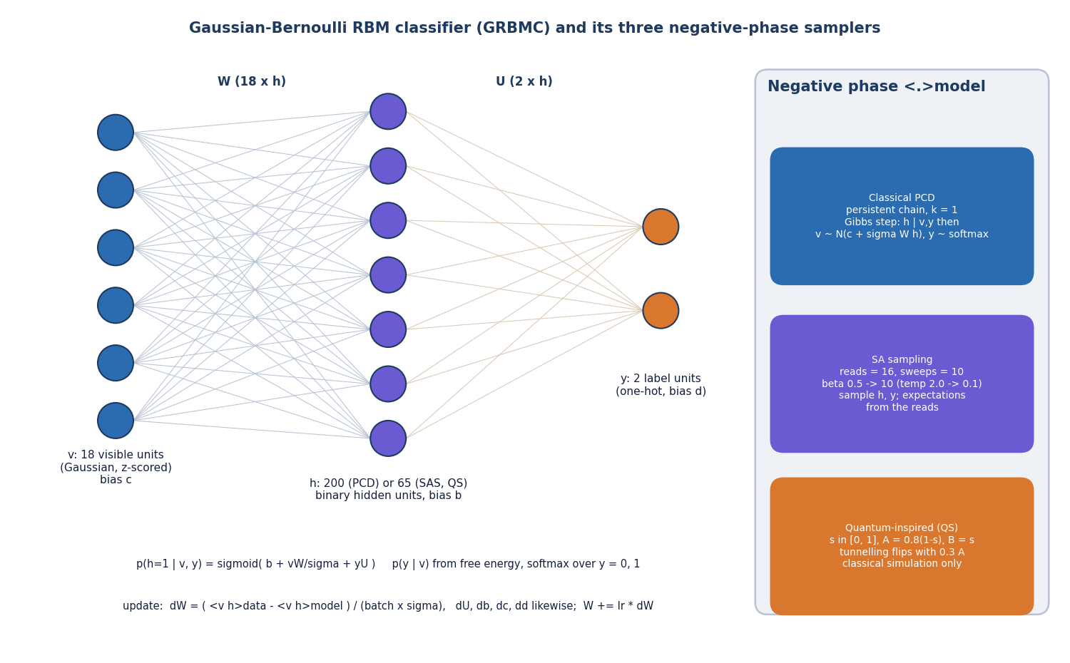
Figure 4: Structure of the GRBMC (visible, hidden and label layers) and the three negative-phase samplers.
All three models read the 18 selected features as visible units and have two label units. They differ in size, batch and sampler, following the paper's hyper-parameter search results (200 hidden units for PCD and 65 for SAS and QS; large batches for the classical trainer and small ones for the annealed trainers [1]).
Table 4: Hyper-parameters of the three trainers as coded
Setting | PCD (classical) | SAS | QS (quantum-inspired)
Visible / hidden / label units | 18 / 200 / 2 | 18 / 65 / 2 | 18 / 65 / 2
Weights (W + U) | 18 x 200 + 2 x 200 = 4,000 | 18 x 65 + 2 x 65 = 1,300 | 1,300
Batch size | 512 (min with training rows) | 32 | 32
Rows used per epoch | all 6,400 | 3,000 (stratified sample, new each epoch) | 3,000 (as SAS)
Negative phase | persistent Gibbs chain, 1 step | 10 sweeps x 2 updates, 16 reads, mean | 10 sweeps, 16 reads, mean, tunnelling
Learning rate | 0.01 exp(-0.08 t) | 0.01 exp(-0.08 t) | 0.005 exp(-0.15 t) + 0.0005
Initial weights | N(0, 0.01), biases 0 | N(0, 0.01), biases 0 | N(0, 0.01), biases 0
Epochs (API default; the lab form starts at 10) | 20 | 20 | 20
Random seed | 42 | 42 | 42
Wall-clock (mean of 5 seeds, 20 epochs) | 4.0 s | 4.9 s | 4.2 s
Time reported in the base paper | 2 minutes | 4 hours | 1.8 hours

The /api/train route accepts a list of modes, an epoch count and a hidden-unit count; the retraining lab of the interface limits epochs to 1 to 50. The classical trainer replaces the default 65 hidden units by 200 and the default batch of 32 by 512, mirroring the paper. The seeding script seed_models.py trains for 10 epochs on the 8,000-row sample; the histories shipped in models/ were written by a 20-epoch run through /api/train, so the saved models and their histories agree (re-evaluating the saved models reproduces the last-epoch history values).
The measured training time is seconds, not hours: the paper's 4 hours for simulated annealing and 1.8 hours for hardware sampling reflect a D-Wave simulator and a cloud queue, while this project's samplers are vectorised NumPy with 10 sweeps and the rows per epoch capped at 3,000. The Paper time column on the Model comparison page shows the paper's reported time beside the measured one and labels the two differently so they are not confused.
Table 5: What the paper describes and what this project implements
Aspect | Base paper | This project
Data | 145 M real transactions, about 19 thousand fraud, balanced to 39 thousand | 39,000 synthetic transactions, 50/50
Visible units | 55 features after filtering | 18 features after filtering
Feature selection | correlation filter and CatBoost importance | correlation filter and random-forest importance
Balancing | manual undersampling (SMOTE, Tomek failed) | manual undersampling by default; SMOTE and Tomek available
Classical trainer | PCD with Gibbs sampling (QARBoM.jl) | PCD with one Gibbs step (NumPy)
Annealing trainer | D-Wave simulated annealing, PIMC-style sweeps | NumPy annealing with batch-mean field and averaged reads
Quantum trainer | real D-Wave quantum annealer through cloud access | classical simulation with a tunnelling-flip term; no hardware
Epochs | 50 (optimum at epoch 25, 34 and 49) | 20 (the lab allows 1 to 50)
Model selection | highest-F1 epoch on the test set | final epoch is the primary figure here; best epoch is also stored
Interface | none described | Flask API with 16 routes and a React application

Selecting the epoch with the highest test F1, as the paper's Table 1 does, reads the test set to choose the model and so slightly flatters it. The project stores both numbers but treats the final-epoch figure as primary; for the shipped models the two agree for SAS and QS and differ strongly for PCD (best epoch 12 with F1 80.0%, final F1 70.9%).

1.7 Decision logic
The application turns the probability of the ensemble into an action with two cut-offs. Above 0.7 the risk level is HIGH and the recommended action is decline and alert; between 0.4 and 0.7 it is MEDIUM and the action is challenge with 3-D Secure; below 0.4 it is LOW and the transaction is approved. The headline label (FRAUD or LEGITIMATE) is separate and flips at 0.5, so a MEDIUM transaction can be labelled fraud while the suggested action is only a challenge. The cut-offs are fixed in app.py and the interface; they are not tuned. Chapter 8 shows the ensemble's precision, recall and F1 across thresholds: at 0.5 the ensemble reaches precision 96.5% and recall 92.5%, and at 0.7 the ensemble flags nothing on the held-out split, so the HIGH band is rarely reached by the averaged score on this data (single models, such as SAS in the Verify screen, can exceed it).
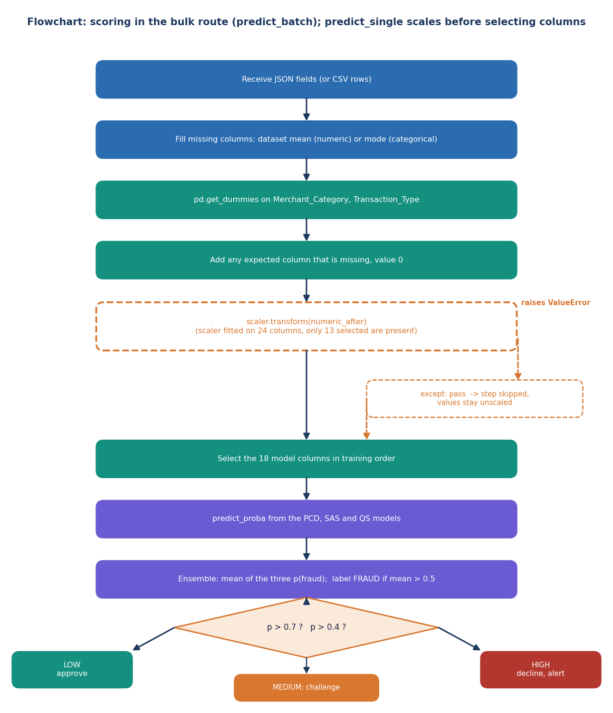
Figure 5: Scoring flow of one transaction, including the scaling step that the batch route silently skips.

2. NOVELTY AGAINST THE BASE PAPER
SecurePay AI does not propose a new learning algorithm and we do not claim one. Its model, the Gaussian-Bernoulli restricted Boltzmann machine classifier, and its three training strategies come from the base paper [1]; the preprocessing steps (one-hot encoding, z-score scaling, a correlation filter, random undersampling, random-forest feature importance) are standard. What this project adds is a runnable, openly readable implementation of that setup on CPU, a complete screening application around it, and a set of measurements that the base paper does not contain: baselines, stability across seeds, threshold behaviour, behaviour at low fraud rates and an audit of the serving path. This section states the difference from the base paper first, then separates what is new from what is borrowed.

2.1 Difference from the base paper
Table 6: Base paper and this project compared (the data differ, so the result columns are not comparable)
Aspect | Base paper [1] | SecurePay AI
Data | Real fintech data, about 145 million transactions, about 19 thousand fraud, balanced by manual undersampling to 39 thousand | Synthetic file of 39,000 rows (50/50), generated by backend/synthetic_data.py; the pipeline works on an 8,000-row sample
Model | Gaussian RBM classifier (visible, hidden, label layers) | Same structure, written in NumPy (backend/rbm_classifier.py)
Training strategies | PCD; simulated annealing through a D-Wave simulator; quantum sampling on D-Wave hardware | PCD; a simplified annealing sampler; a classical simulation of a transverse-field sampler (no quantum hardware)
Hyper-parameters | Grid search over hidden units and learning-rate schedules; 200 / 65 / 65 hidden units, batch 512 / 32 / 32 | Taken from the paper (200 / 65 / 65 hidden, batch 512 / 32 / 32), not searched
Epochs and time | 50 epochs; about 2 minutes, 4 hours, 1.8 hours | 20 epochs; 4.4 s, 4.2 s, 3.4 s measured on one CPU
Reported F1 (PCD / SAS / QS) | 83 % / 88 % / 84 % at the best epoch on real data | 70.9% / 94.4% / 94.3% at the final epoch on synthetic data (best-epoch values: 80.0% / 94.8% / 94.3%)
Baselines | None reported | Logistic regression, random forest and XGBoost on the same split (F1 96.7%, 96.3%, 96.5%)
Interface | None | Flask API with 16 routes and a React application with seven screens

2.2 What is new here
1. An open, deployable implementation. The base paper used a Julia package and cloud access to quantum hardware. Here the same model trains on a laptop CPU in seconds (about 4 s for 20 epochs) and sits behind an API and a browser interface, so the pipeline can be inspected, rerun and extended.
2. Baselines on the same split. Logistic regression, random forest and XGBoost reach F1 96.7%, 96.3% and 96.5% on the split on which the ensemble reaches 94.5%. On this data the simple models are better, which the base paper could not show because it reports no baselines.
3. Stability and threshold analysis. Five retrainings give F1 69.2 +/- 23.1 for PCD but 94.4 +/- 0.1 for SAS. A threshold sweep shows that the shipped PCD model ranks transactions well (ROC-AUC 0.986) but is badly placed at 0.5 (accuracy 58.8%).
4. Imbalance study. With 1% fraud, undersampling lowers the precision of logistic regression, random forest and XGBoost to 0.20, 0.22 and 0.19, while training without resampling keeps it above 0.95. This extends the base paper's remark that SMOTE and Tomek links did poorly [1] with measured numbers.
5. A serving-path audit. Reading the code against the measurements exposed that the single and bulk routes skip feature scaling, so accuracy on a fresh batch drops from 94.8% to 50.2%. The defect, its cause and its measured effect are documented rather than hidden (see the system-testing and results chapters of the report).

2.3 What is not new
• The restricted Boltzmann machine, contrastive-divergence training and the Gaussian-Bernoulli variant [22], [23], [24], [25], [28].
• The idea of training an RBM with an annealing or quantum sampler [30], [31]; the samplers here are simplified approximations of it.
• One-hot encoding, z-scoring, random undersampling and random-forest feature ranking [12], [13], [19].
• The evaluation metrics (precision, recall, F1, ROC-AUC) and the argument that accuracy is misleading on imbalanced data [16], [17], [14].

2.4 A modest reading of the novelty
The contribution is engineering and measurement, not a new method. No claim of quantum advantage is made or supported: the quantum-inspired sampler is a classical simulation, the data are synthetic, and the simple baselines outperform the RBM models on this split. The value of the work lies in showing, with reproducible scripts, what the base paper's approach does when it is rebuilt from its description and checked against ordinary baselines and against its own serving code.

3. KEY CONTRIBUTIONS
The work makes the following contributions, each backed by code in the repository and by a measurement in Chapter 8.
1. A complete NumPy implementation of a Gaussian-Bernoulli RBM classifier with three trainers (persistent contrastive divergence, a simplified simulated-annealing sampler and a classical simulation of a quantum-inspired sampler), including the QUBO matrix view (backend/rbm_classifier.py, samplers.py, train.py).
2. A preprocessing and balancing pipeline that follows the base paper (one-hot, z-score, correlation filter, undersampling, importance-based selection of 18 features, stratified 80/20 split) with SMOTE and Tomek-link options (backend/preprocessing.py).
3. SecurePay AI: a Flask API with 16 routes and a React interface for single checks, CSV bulk screening, analytics, model comparison and a retraining lab, with risk bands at 40% and 70%.
4. A reproducible evaluation (scripts/run_experiments.py) covering the shipped models, three baselines, five seeds, a threshold sweep and a 1%-fraud variant with four imbalance strategies, whose output feeds every table in this report.
5. An honest comparison with the base paper: the base paper's Table 1 is reproduced beside this project's results with an explicit statement that real and synthetic data are not comparable.
6. A serving-path audit that found and quantified a silent scaling failure (accuracy 50.2% as served against 94.8% when scaled), together with a latency measurement (median 17 ms per check) and a read-only smoke test of the API (20/20 checks pass).
7. Generated documentation: diagrams, result figures, screenshots and this report are produced by scripts from the code and the measured files, so they can be regenerated.

